Supporting information for
Recognizing and stabilizing miR-21 by chiral ruthenium(II) complexes
YIN FENG^{1#}, JING SHU^{2,3#}, LIANGZHONG YAO^{1*}, YUTAO LAN^{2,4*},LIANBAO YE^{2,3,5}, WENJIE MEI^{2,3,5*} and YING DING^{1,2*}
¹ The First Affiliation Hospital, Guangdong Pharmaceutical University, Guangzhou 510062, China.
² Guangdong Province Engineering Center for Molecular Probe & Biomedical Imaging, Guangzhou, 510006, China.
³ School of Pharmacy, Guangdong Pharmaceutical University, Guangzhou, 510006, China.
⁴ School of Nursing, Guangdong Pharmaceutical University, Guangzhou, Guangdong, 510006, China.
⁵ Guangzhou key laboratory of construction and application of new drug screening model system, Guangdong Pharmaceutical University, Guangzhou, 510006, China.

Contents:
Figure S1. The ESI-MS spectra of Λ-1(A) and Δ-1(B);
Figure S2. The ¹H NMR spectra of Λ-1(A) and Δ-1(B);
Figure S3. The ¹H ¹H COSY spectra of Λ-1(A) and Δ-1(B);
Figure S4. The HPLC analysis of Λ-1(A) and Δ-1(B);
Figure S5. The amplification plot(left) and dissociation curve(right) of Q-PCR of miR-21 transcript expression profiles of Λ-1 (A) and Δ-1 (B) at various confluences .

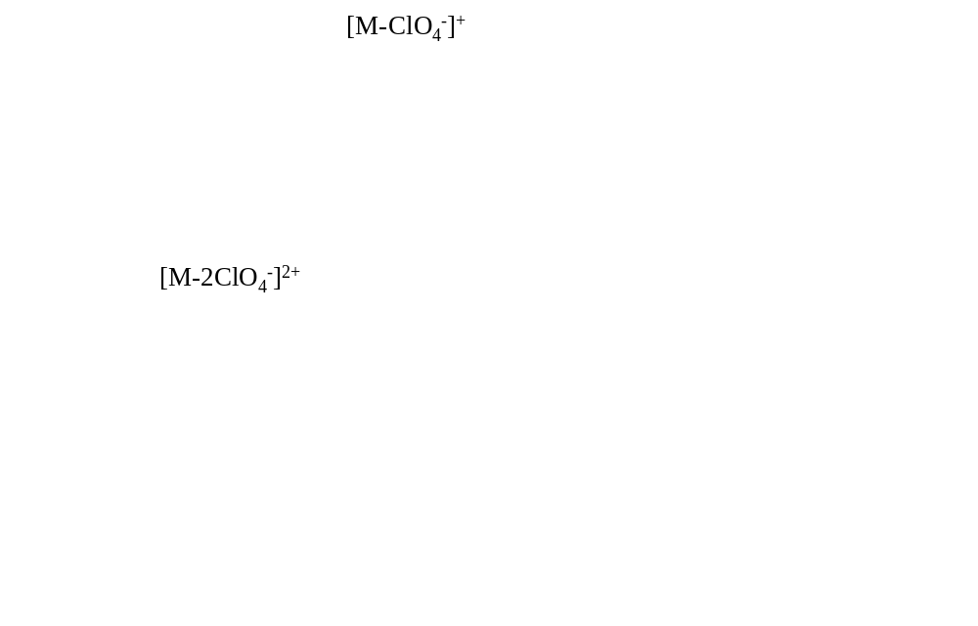
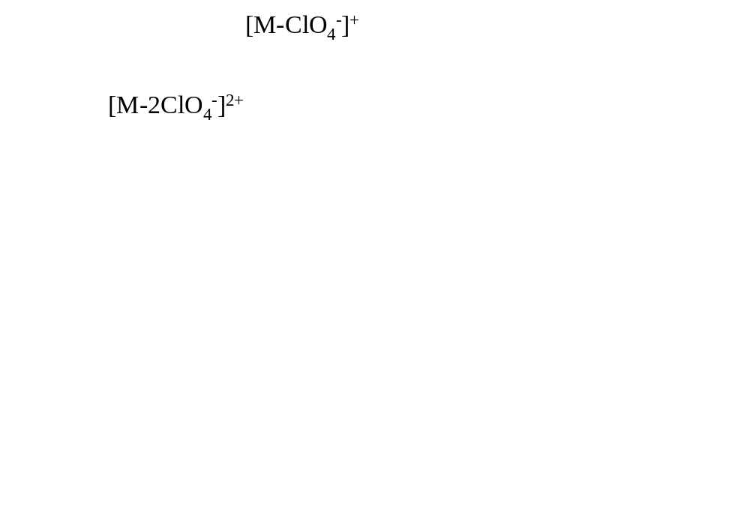
Figure S1. The ESI-MS spectra of Λ-1(A) and Δ-1(B).

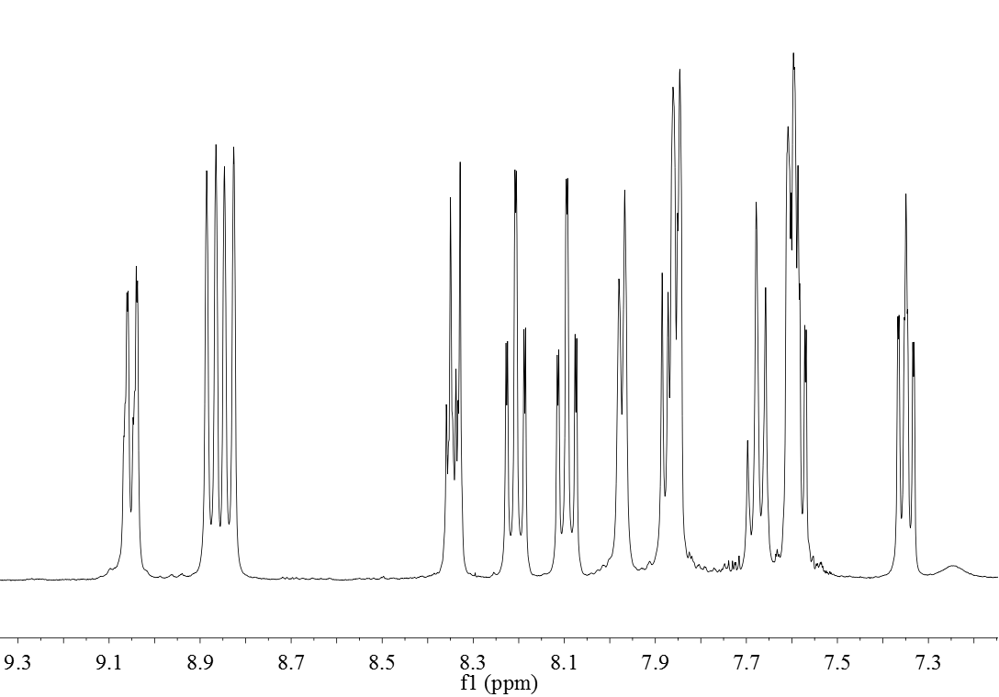
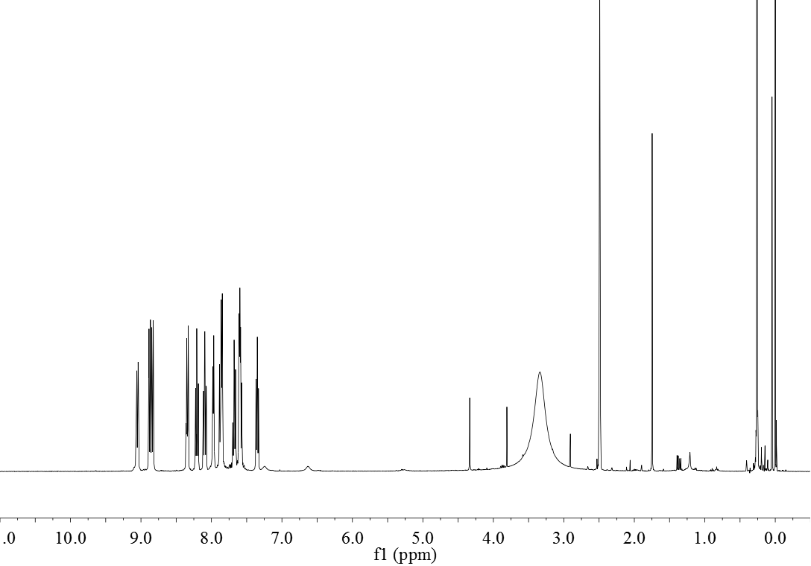
A
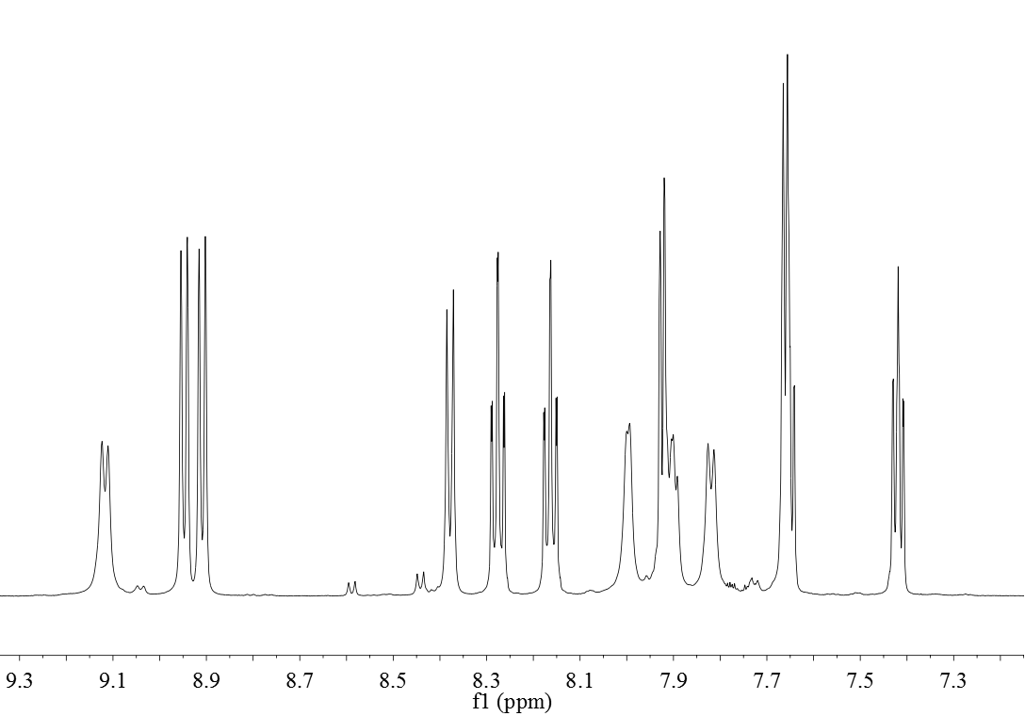
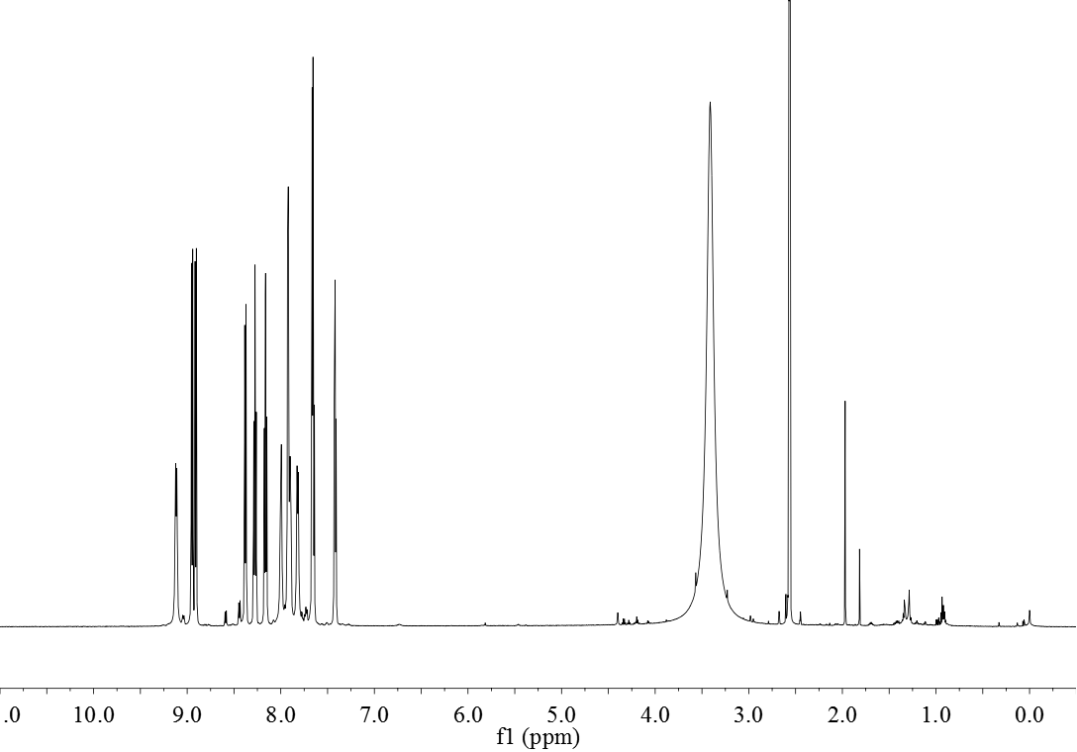
B
Figure S2. The ¹H NMR spectra of Λ-1(A) and Δ-1(B).

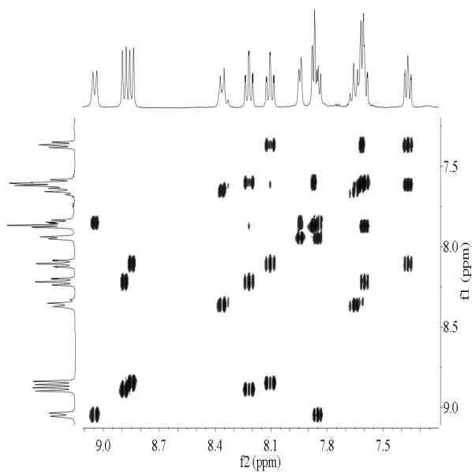
A
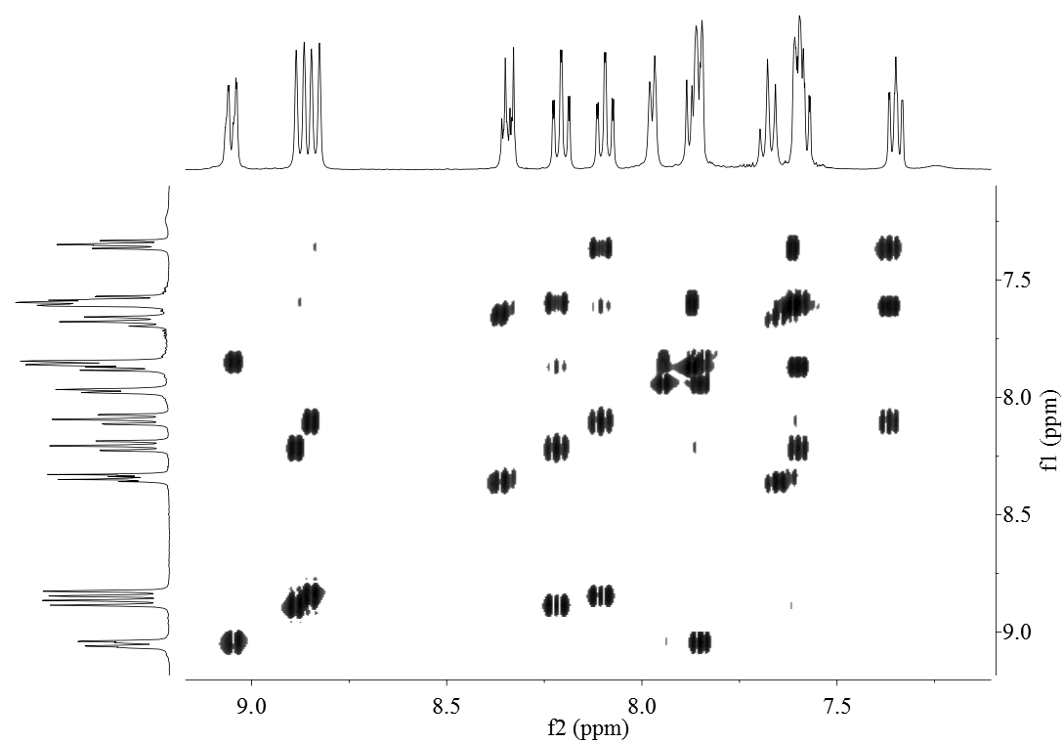
B
Figure S3. The ¹³CNM spectra of Λ-1(A) and Δ-1(B).
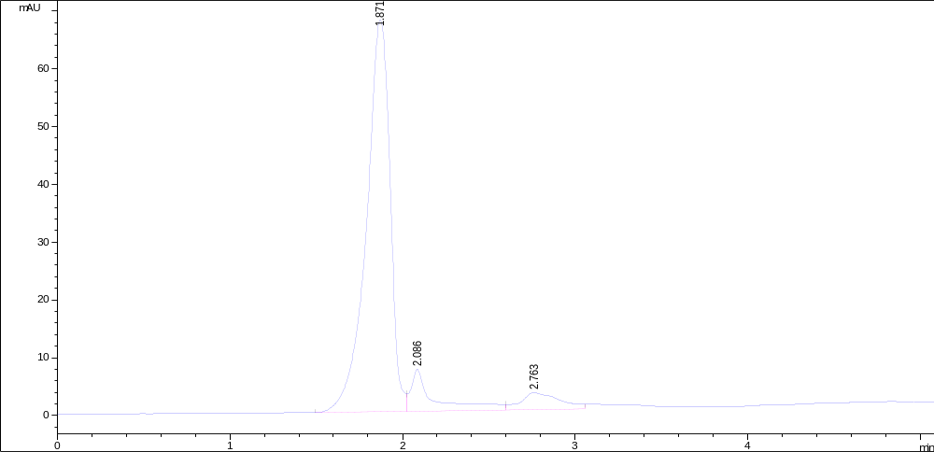
A
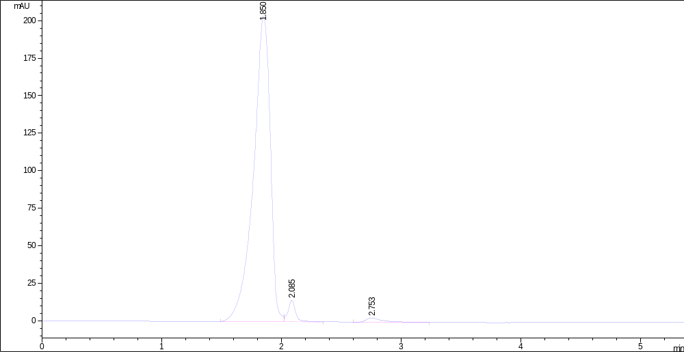
B
Figure S4. The HPLC analysis of Λ-1(A) with purity of 94.934% and Δ-1(B) with purity of 95.654%.

Figure S5. The amplification plot and dissociation curve of Q-PCR of miR-21 transcript expression profiles of Λ-1 (A) and Δ-1 (B) at various confluences.
Figure S6. The stability of Λ-1 (10 μM) and Δ-1 (10 μM) in distilled water tested by UV-vis spectra in every day for 7 days.
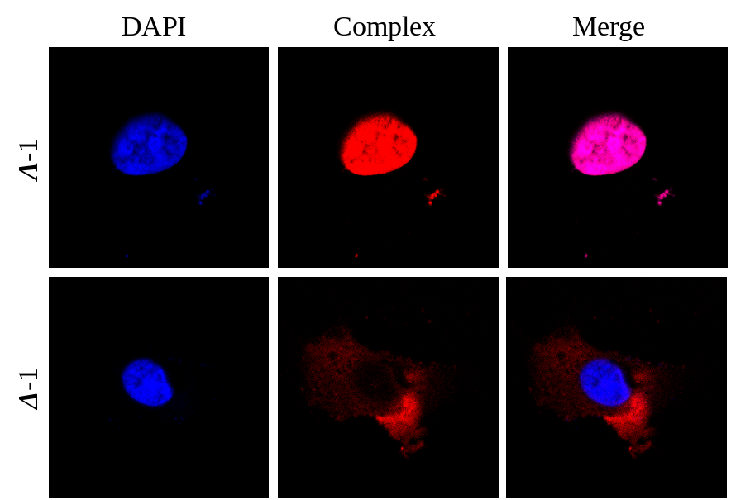
Figure S7. Cellular localization of Λ-1 and Δ-1 in HepG2 cells. Cells were treated with Λ/Δ-1 (5 μM) for 6 h. .

